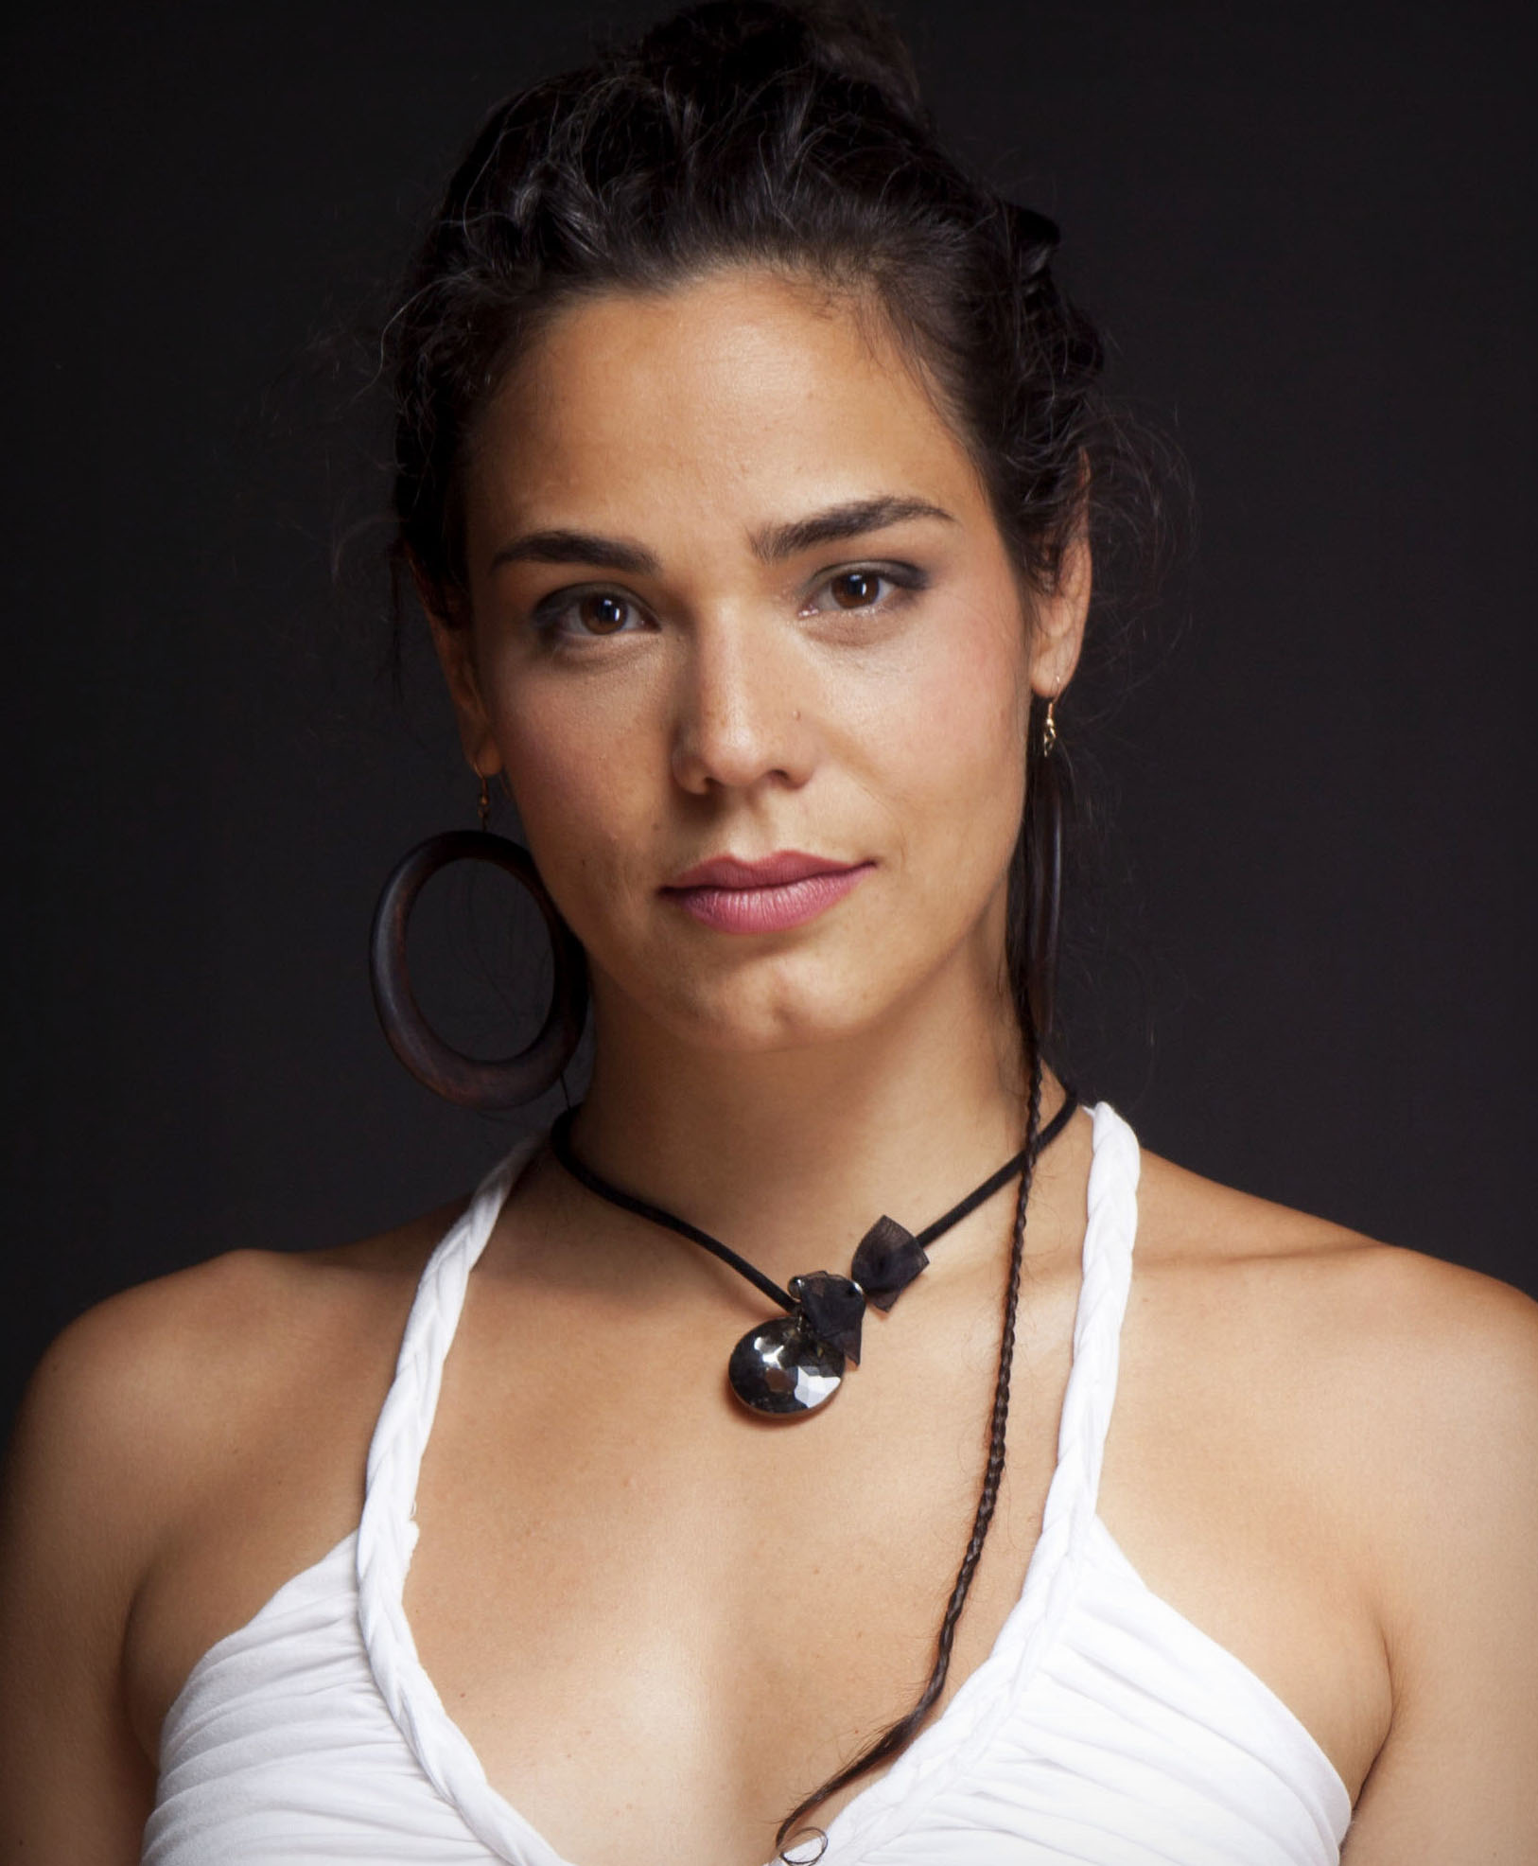
SANJA MARKOVIC
www.sanjamarkovic.com
email:markovichsanja@gmail.comtel: +381 60 32 55 819

EDUCATION

• Master of Music (M.M.), Music Academy in Belgrade, 2008
Major: Music Pedagogy and Theory

• Piano studies in "Levine School of Music", Washington D.C., USA, 1994-1999
Class of Prof. Eva Pierrou

• Piano Master class, "Eastern Music Festival", Greensboro, NC, USA, 1994
Class of Prof. Dana Barnett

• Internship at "Water Music" Studio, Hoboken, NJ, USA,
Winter 2010-2011
Mentor: Rob Grenoble - music producer

WORK EXPERIENCE AND PROJECTS
• Band leader, composer, arranger, vocal and instrumental performer - Sanja "Ascension" project, Belgrade Jazz Festival, October 2017

• Band leader, vocalist and guitarist in a jazz band "Brazilian Jazz Collective", 2014 to present

• Musician (guitar, piano and voice) and theater actress in a play "Birthday of Mr. Nusic" - Zvezdara Theater, Belgrade 2014 to present
• Jazz Singing, Solfeggio, Music Theory and Instruments Teacher
- Music School “Josif Marinković”, Vršac, Serbia 2012

• Instrumental (soprano and tenor saxophone) and Vocal Performer in a band "Naked" performing at the "Peep Show" stage on "EXIT" festival, Novi Sad, Serbia
July 2012

• Arranger and jazz vocalist with Big Band RTS, Belgrade and Valjevo Jazz Festival, Serbia
December 2011 and October 2012.

• Vocal Jazz and Latin Performer in a "Mambo Stars" band, Belgrade, Serbia
March 2011 to today

• Piano Teacher in "Florentine” Music School, Manhattan, NY, USA
October 2010 - March 2011

• Instrumentalist (piano, tenor saxophone) and Arranger in a theater play "Solo for
Breht", “Beogradskodramsko” Theater, Belgrade and "Dounau Fest", Ulm, Germany,
2010

• Instrumentalist (saxophone and percussion) in a project "Mama Duna"
"Dounau Fest", Ulm, Germany, September 2010

• Musician and Actress in a theater play "Welcome to Serbia", “Zvezdara” Theater,
Belgrade, Serbia
Activity: instrumentalist (saxophone, piano, trumpet, accordion, frula, dipla, goč),
vocalist, dancer, May 2006 to today

• Member of a Choir Ensemble of “PozorištenaTerazijama” Theater, Belgrade, Serbia
Musicals: Chorus Line, Chicago, Queen of the Gypsies, Maratoncitrčepočasni
krug, Spusti se naZemlju, Svetlostipozornice, Kiss me Kate, 2005-2008

• Jazz Vocalist
Performance at the Belgrade Jazz Festival, performances with various established jazz musicians and Big Band RTS
Clubs and concert halls: Kolarac, Dom omladine, and many jazz clubs (Belgrade, Serbia),
Madam's Organ (Washington, D.C., USA) and various venues in NYC, Jazz Festival
(Vos, Norway), Valjevo Jazz Festival
2005 to today

• Pianist for a movie soundtrack "Diši duboko"
Director: Dragan Marinković
2004

AUTHOR WORK

• Recording artist, composer, arranger, vocalist, instrumentalist (soprano and tenor saxophone) and music producer - author album "Ascension", recorded July and August 2017

• Composer, arranger, vocalist and producer for a Leo Burnett client, NYC, USA, 2012
• Composer, pianist and producer for an animated movie "The Rise and Fall of Art", Aleksa Gajic, 2012

• Composer and Sound Designer for a 2012/2013 music catalog by ”Muserk Music Catalog”, NYC, US

• Big Band Arranger; composition "Mystery of Man" (author: Sarah Vaughan
and Francy Boland/lyrics: Pope John Pole II), December 2011

• Composer and Member of Roster List (composing, playing, production, mix and
post-production) for United Nations; campaign: “UNiTE to End Violence Against
Women”, NYC, USA, November 2011

• Composer (composing, playing, production, mix and post-production) for a TV
commercial "Shelter Is a Part of My City!", May 2011

• Composer (composing, playing, production, mix and post-production) for a series od fashion videos by “Le Image" studio, Brooklyn, New York, USA, 2011 to today

• Member and Co-author of a musical group "Secondhanders"
Activity: co-author i co-arranger of prerecorded material (production, mix and
post-production), live: vocalist, saxophonist, playing mbira and percussion
Performances: "Infant" Festival, ”CvijetaZuzorić”, “Studentski grad”, “SKC”, "Dounau
Fest",Ulm, Germany, March 2009 - October 2010

• Co-author, Co-arranger (production, mix and post-production), Vocal, Saxophone,
Acting in a theater play "Secrets of MomčiloNastasijević", "Dah Theater - Center for
Theater Research", Belgrade
Performances: “KulturnicentarBeograda”, residency of MomčiloNastasijević in GornjiMilanovac, April 2009

• Composer (composing, playing, production, mix and post-production) for a TV
documentary "How Has A People Happened", "Brendon" production, March 2009

• Composer (composing, playing, production and mix) for TV and radio commercials in cooperation with studio "Etar"
Clients: "Pionir" Subotica, "Farma plus", Ministry of Ecology
January 2009 - May 2010

• Assistant Director, Co-producer and Music Supervisor for a documentary about
Jazz drummer BranislavLalaKovačev
Production: V.S.T. (Visual Standards & Technology), 2009 to today

MISCELLANEOUS

• Owner of a vehicle and Virginia drivers license (category B)

• Owner of a home music studio; recording, editing, mix and production

• Knowledge of programs: MS Office; music production programs: Nuendo, Cubase, Melodyne, Pro Tools, Logic, Wave Lab, Sibelius, Acid Pro; video production programs: Adobe Premier Pro, Final Cut Pro; Photoshop

• Volunteering for nature preservation (Zlatibor, Kopaonik, Danube river banks)

• Teaching private lessons: piano, solfeggio, music theory, counterpoint and working in music programs

• Languages: English, Serbian, basic Spanish and Russian

